Data Flow Diagrams & User Stories
Project Name: Online Complaint Registration System
Date: 18 June 2026

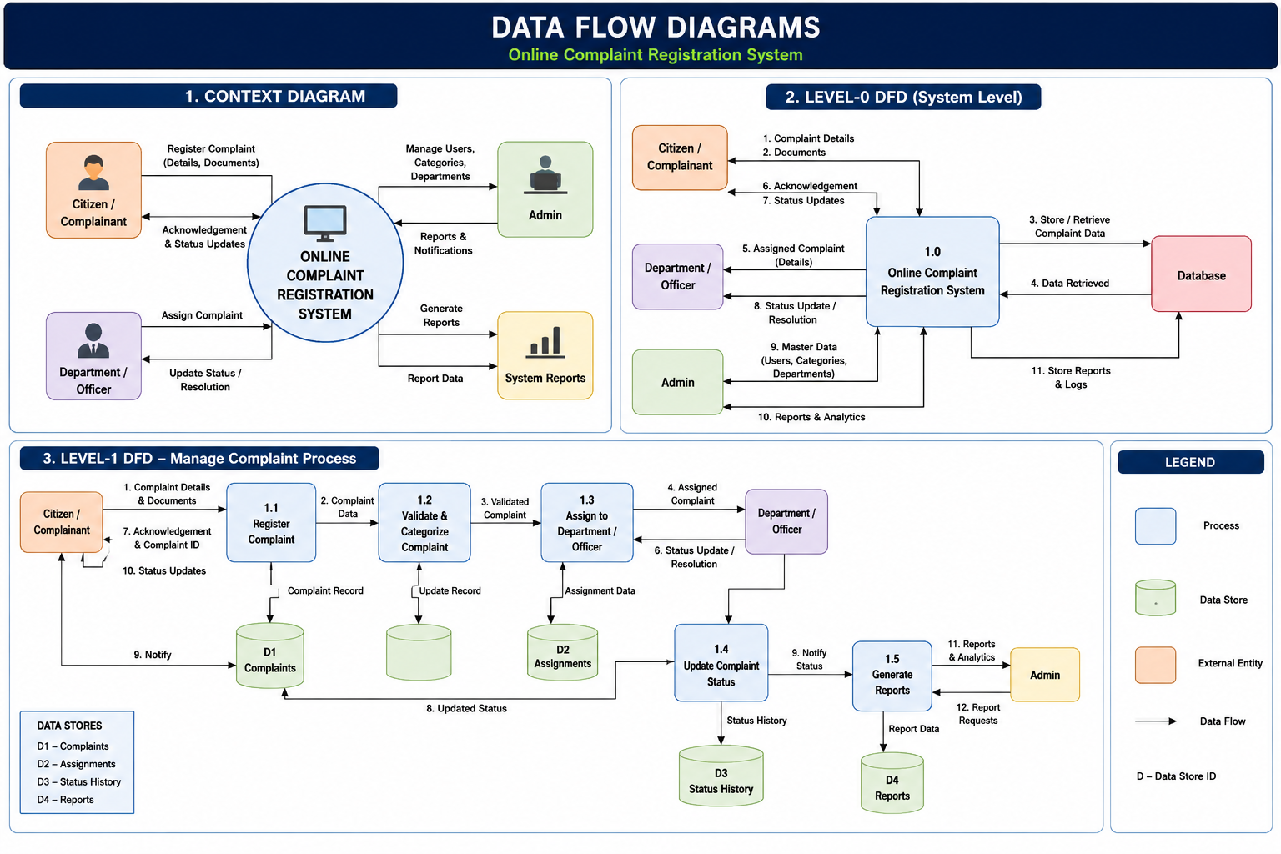

Data Flow Diagram Overview
External Entities:
• User/Citizen
• Administrator
Processes:
1. User Registration/Login
2. Submit Complaint
3. Upload Evidence
4. Complaint Verification
5. Complaint Assignment
6. Status Update
7. Complaint Resolution
Data Stores:
• User Database
• Complaint Database
• Evidence Database
• Status Database

Context Diagram (Text Representation)
User --> Online Complaint Registration System <-- Admin
User submits complaints and receives updates.
Admin manages and resolves complaints.

Level-0 DFD
User -> Registration/Login -> Complaint Submission -> Complaint Database -> Admin Dashboard -> Status Update -> User

User Stories
User | Epic | USN | User Story | Acceptance Criteria | Priority
Citizen | Registration | USN-1 | Register using name, email and password | Account created | High
Citizen | Login | USN-2 | Login securely | Dashboard opens | High
Citizen | Complaint | USN-3 | Submit complaint | Complaint ID generated | High
Citizen | Evidence | USN-4 | Upload supporting files | Files saved | High
Citizen | Tracking | USN-5 | Track complaint status | Status visible | High
Citizen | History | USN-6 | View complaint history | History displayed | Medium
Admin | Management | USN-7 | View all complaints | Complaints listed | High
Admin | Assignment | USN-8 | Assign complaint | Officer assigned | High
Admin | Status | USN-9 | Update complaint status | Status updated | High
Admin | Resolution | USN-10 | Resolve complaint | Marked resolved | High
Admin | Reports | USN-11 | Generate reports | Reports available | Medium
System | Notification | USN-12 | Send email notifications | Users notified | Medium

Sprint Allocation
Sprint-1: Registration & Login
Sprint-2: Complaint Submission & Evidence Upload
Sprint-3: Complaint Tracking & Notifications
Sprint-4: Admin Dashboard, Reports & Resolution

